Robins Olds surely knew how to talk to his F-4 -- from Nolly. It is a great tribute to his Lady. A great tribute to the F-4 from an amazing fighter pilot.
Like a brooding hen, she squats half asleep over her clutch of eggs. Her tail feathers droop and her beak juts forward belligerently. Her back looks humped and her wing
tips splay upward.
Sitting there, she is not a thing of beauty. Far from it. But she is my F-4, and her nest is a steel revetmenther eggs 6, M-117, 750-pound bombs. This avian has fangsvery unbird-like. They nestle under her belly and cling to her wings. She is ready to go ... but so am I.
She receives me and my backseater, and we become a part of her as we attach ourselves to her with straps and hoses and plugs and connectors.
A surge of juice and a blast of compressed air and she come alive. We are as onetied togetherthe machine an extension of the manher hydraulics my musclesher sensors my eyesher mighty engines my power.
She screams and complains as we move through shimmering heat waves along an endless expanse of concrete. Final checks . . then her nose pointed down nearly two miles of runway . . and we are ready.
Throttles forward . . then outboard
THUMP, THUMP
The afterburners kick in. Now my bird roars and accelerates rapidly toward her release from mother earth, leaving a thunder behind that rattles windows and shakes the insides of those who watch.
I look over at my wingmen as we climb effortlessly toward a rendezvous with our tanker. All is well with them, and I marvel again at the transformation of our ugly duckling into a thing of graceful beautyyet shes businesslike and menacing, thrusting forward and upward with deadly purpose. Refueling done, we drop off
and lunge forward, gathering speed for this days task.
We hurtle across the Black, then the Red Rivers, pushing our Phantoms to the limit of power without using afterburners, weaving and undulating so as not to present a steady target for the gunners below.
Then a roil of dust down to our left, and the evil white speck of a surface-to-air missile rises to meet us. We wait and watch. That missile is steady on an intercept course, and we know we are the target.
Then, on signal . . we start down. The missile follows
HARD DOWN . . .
NOW !
Stick full forwardthe negative G forces hanging us in our straps. The missile dives to follow.
And at a precise moment we . .
PULL PULL PULL
as hard as we can . . positive Gs now slamming us into our seats with crushing force.
Our heavy bird with its load of bombs responds with a prolonged shudder, and we are free for the moment, the missile passing harmlessly below, unable to follow our maneuver.
On to the targetweaving, moving up and down, leaving the bursts of heavy flak off to the side or down below. The F-4 is solid, responsive, heeding my every demand quickly and smoothly.
We reach the roll-in point, and go inverted, pulling her nose down, centering the target in the combining glass as we roll into our 70-degree dive toward the release point.
My Phantom plunges toward the earth through an almost solid wall of bursting flak. Then PICKLE ! And the bird leaps as her heavy load separates and we pull with all our force around to our egress heading.
There are MiGs about.
And my F-4 becomes a brutal beast : slamming this way,then thatsnarling with rage . .turning, rolling, diving, hurtling skyward like an arrow .. plunging down with savage force.
The melee over, the rivers crossed, and headed for our post-strike refueling, and my bird is once again a docile, responsive lady, taking me home, letting my heart beat slow, giving me comfort in having survived once again.
I gather the flock close by, and we slowly circle each othertop, bottom, and each side, looking for flak damage, rips, leaks, jagged holes. None found, we press on to meet our ticket home and gratefully take on fuel from our tanker friends.
A bit of follow-the-leader up and over the beautiful mountains of dazzling white nimbus, just to relaxto enjoy the special privilege given us in flying this magnificent birdand the home runway lies ahead there near the little town of Ubon-ratchitani.
Landing done, post-flight checks finished, engines shut down, and my F-4 vents its tanks with a prolonged sigh, speaking for both of us, glad its over, anticipating a brief respite before the next days work.
Its an unusual pilot . . who doesnt give his bird a private touch of loving gratitude before he leaves her nest.
Robin Olds
Brig Gen, USAF (Ret )
Garry Cooper’s zero always shot down in Australia at air shows throughout Australia. Garry is an ACA member and was a RAAF FAC in Vietnam flying O-1s for the 9ID in 1968. The aircraft had been a Canadian Harvard Mark 4T-6 which was converted in 1968 as a replica of a WWII Japanese Zero for the filming of the movie Tora Tora Tora and Empire of the Sun. The replica is within a few centimeters of a Zero’s dimension. He is shown in the aircraft in many of the Australian air shows he flies in and is always got to be shot down since he represents the enemy of WWII.

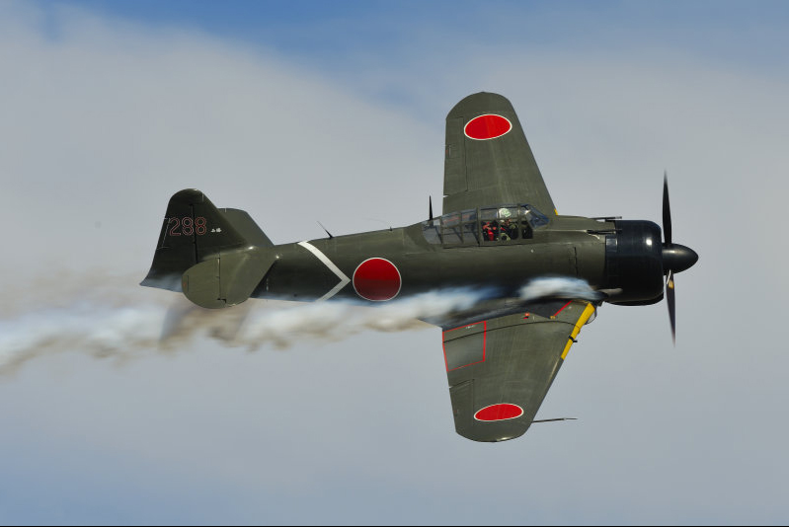

Siegel Martin "Dick" Dickman , 1926 – 2009, Obit of an original Air Commando
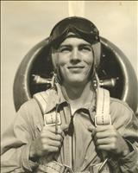On June 10, 2009, "Dick" had his homecoming in Heaven. This was the day he was scheduled to come home from the hospital following 11 weeks of care and treatment for cancer.
He was born on June 22, 1926, in Toledo, Ohio, raised in the area of Los Angeles, served his country around the world, and made Fort Walton Beach, Fla., his home.
In 1945, he joined the Army Air Corps, which later became the U.S. Air Force, and served his country for over 24 years. He was a test pilot and also a fighter pilot. He flew most planes, from P-51 to F-104 and the B-26. He defended freedom and represented our country in the Panama Canal Zone, Guatemala, Iran, Republic of the Congo, and Germany. In Korea he flew more than 100 combat missions, sometimes eight per day, and 66 in Vietnam.
He was a silent hero, the recipient of many medals, including multiple awards of the Distinguished Flying Cross and the Air Force Commendation Medal. In Korea, his plane was brought down by enemy fire and he avoided capture when rescued by helicopter and crew. He also survived another plane crash but this did not alter his life-long love of flying.
After retirement from the Air Force he worked at the Eglin Aero Club teaching others to fly. When he could no longer fly he continued to go there every day that he was able to drive, until his recent hospitalization. During his life he logged over 10,000 flying hours.

Allen Cates, setac@bellsouth.net, Air America pilot Recalling C-47 949 or why I flew for Air America
If you could include some of these facts in the ACA Newsletter, I would appreciate it. Some years ago I wrote this letter to a man who had worked on 949 while in the Air Force. He somehow knew I had flown the aircraft with Air America and he wanted to know it's fate. Mr. Matheson's son found the letter somewhere and forwarded it to his sister and she asked me about it. Apparently the Air Force man placed it on a blog of his concerning his history with C-47 aircraft. It's a good story and true. I thought you would find it interesting. You might also like to listen to this song. It is in French, but sang by a Vietnamese woman. You might have heard it before. http://www.visualgui.com/motion/BonjourVietnam.html
Allen THE CRASH OF 949

The crash occurred in I Corps near the city of Hue. Four years earlier, I had been to Hue several times as a Marine Corps helicopter pilot. Many of our missions involved transporting troops into an LZ that was reported by intelligence to be occupied by Viet Cong. Hue was a staging area that was used because it was considered safe. But, on one occasion one of our pilots became a casualty right inside the city limits.

We had been waiting for hours to launch. Old Vietnamese ladies would come by with small loves of freshly baked bread that we could purchase if desired. Small boys would mysteriously appear with buckets full of iced down soda pop. Where the ice came from, and how far they traveled was beyond me, but when they were empty they would gleefully run off to refill them. I had never been in a war before, and this did not seem to be the way I had imagined it. You could look over at a nearby road and see people going in both directions like this were the most peaceful place in the world.

I found out that the situation changed very fast. Without warning we heard the word to mount up! We were headed into battle and it took about 15 minutes to get there. It was as quickly over as it began. We charged in at low-level running on 10% adrenaline and 90% seven up. A spotter plane had dropped a smoke grenade in the LZ so we could see where the wind was. There was red smoke also, indicating that that LZ was hot. I did not hear any ground fire, but it was years later that I discovered that ground fire sounded like distant pop corn unless you were hit. The troops were eager to get to it and many would jump out before we had reached a full stop. Almost before you stopped you were empty and slamming on full power to clear the zone.

15 minutes later we were back at Hue with instructions to wait until the troops cleared the village before going back in to pick them up. As soon as I shut down I heard someone yelling for a medic. Sure as hell someone had been hit. I jumped out and ran up the line to where I heard the yelling. One of our pilots was half sitting and half lying in the helicopter. He was holding his lower abdomen and in obvious pain. The medic was there, but he looked perplexed. I leaned over to get a better look. Everybody was staring, but no one said a word. The pilot was not a member of our squadron. We all knew him from the states, but he was attached to the group and was only filling in. He was wearing a flight suit with a very large zipper. When the word came for us to mount up, he was relieving himself near the tail of the chopper. He yanked up his zipper and zipped his business up at the same time. He was fairly well endowed and he had zipped up about 4 inches of skin. You could see how the skin had folded in and out over zipper. He had tried to unzip it but the pain was too great and he had flown the entire mission half sitting and half standing in the cockpit.

The medic was able to unzip it with a pair of pliers. There was some blood. The last time I saw him years later he was a full colonel. He was not wearing a purple heart.

They later named that strip Hue Citadel. Maybe it was always that name. Hue Phu Bai was the new big strip further to the south. That was where the C-47's landed. All of the C-47's that Air America had in Vietnam were on loan from the US Military and apparently from the Air Force. I suppose the whole serial number was on the logbook, but the tail number only showed the last three numbers.

When I finished my tour in Viet Nam I had been reassigned to MAG 36 in Santa Ana, CA. There was not much there since the Viet Nam war has began in earnest in the summer of '65. There was only one lonely old UH34D helicopter painted white that you could fly if you wanted. I asked for a transfer to fly jets and was refused. I asked for a transfer to the training command to fly T-28's and was accepted. I wanted to go back to Viet Nam, but was refused. All the squadrons that would soon deploy were filled. I was a captain by then. I was a Vietnam veteran and I thought I knew how to fly. I was 25 and bored and something had to change. I bought a brand new 1965 Pontiac GTO for $3000.00 with 3 carburetors and 360-horse power. It was the closest thing to a jet I would fly until 14 years later. I sold it to my brother for $1500.00 a year later. It was not enough to quench my desire to go back to South East Asia where to me everything made sense. The only way I could do it was to resign my commission and hire on with Air America.

In December 1966 I was in Bangkok with all the familiar smells and sounds that I had come to love. After finishing ground school, I had been sent to Saigon. I was to fly as co-pilot for at least 6 months and flight training started immediately. I soon found out that I really did not know how to fly. The C-47 was probably the easiest airplane in the world to fly, but I never flew a tail dragger much and I made some horrific landings and takeoffs when I first started. Almost all of the captains were 20 years older than I. Finally a kind gentleman by the name of Lee Howell provided me with some valuable advice. "Steer it like a car Cates. That's all there is to it." Sure enough it worked. The minimum runway length for the C-47 was 1500 feet, which is damn short when approaching, or taking off with a full load. The only navigation aid we had was ADF. So, for the most part our flying had to be conducted VFR, or versions thereof.

After a certain amount of time the aircraft had to be completely overhauled. This operation was conducted in Tainan, located in the south of Taiwan. Regardless of the weather conditions, if was time to go, we went. I only made the trip once, but after taking off from Danang, I only saw the ground when we touched down in Hong Kong for refueling. I am not exactly sure how the hell we got there. There was no way to predict the winds, so time and distance was not even a close approximate. No one could hear us for position reports. It was strictly stick and rudder-needle and ball, and that is how we flew in Vietnam.

There was absolutely no coordination with the military, and sometimes it was a little scary. All too often I found myself in the middle of a bombing pattern surrounded by F-100's who probably wanted to know who the heck I was.

During the monsoon season I Corps was dry, and of course wet during the dry season. If the weather was bad at Hue, I would take off and turn east toward the sea. When I was feet wet I would stay low and follow the coastline to Danang. If it were below visual flight rule minimums at Danang I would contact approach control and ask for a GCA. Usually they accommodated if they could see me. We did not have transponder and if there was a lot of traffic we had to get down the best we could. On the day that 949 crashed, the pilots were Captain Howard Kelly and First Officer Milton Matheson.

Both pilots were retired military and had received ample training. Howard had been flying in Vietnam in the C-47 for several years. He probably had several hundred hours in just 949. So how did this accident happen? We may never know for sure. Howard had bailed out over Germany in WW-2 and walked out to Spain a hero. He was very proud of the Air Medal he had received from the experience. Perhaps Howard was shot down and the evidence obscured by the crash damage. The crash was listed as pilot error, but many other times that evaluation had proved to be false.

After taking off from Phu Bai the tower had told Howard there was reported ground fire near the airport. I would assume that Howard would turn east and run to the coast to get feet wet. I had flown 949 several times. It was as good an airplane as could be found and there was nothing mechanically wrong with it that was reported. The plane never slowed down until it hit the mountain at full force. Howard was ejected from the airplane and was found 1500 feet from the crash. Death was instantaneous. To the best of my knowledge, this was the only Air America C-47 that was destroyed in Vietnam, and each one flew daily for several years and logged thousands of hours.

Mr. Matheson was only going to stay long enough to save money for an ice cream franchise. I hope his family was able to carry on. I did not know Howard well. I liked flying with him because he was always in good humor. I hope both pilots rest in peace.

Allen Cates

Jay Norton, nimrodj@earthlink.net, Getting your tail shot off.
I flew the Caribou on my first tour in SEA just before going to A-26's at NKP. Another photo of this C-7 was printed in the Stars & Stripes. This Caribou was not from my Squadron but the Loadmaster on board was a Msgt and an ex-C-124 Loadmaster and part of my "crew" during our check out at Ft Benning, GA. The 105's were just off the end of the runway. Their standard procedure was to set up the 105 according to the coordinates they were receiving from the field. Then one of the gun crew would look at the sky to make sure no helicopters or fixed wing were in the vicinity. They followed procedure, then got a last minute course correction from the field, put in the correction but did not re-do the visual check before firing. The Caribou in the meantime was overhead on downwind and performing a ground fire avoidance pattern where you would pull the throttles back to idle and do a fast 180 degree decent to the runway. Consequently they did not make a lot of noise. The Caribou was in this maneuver during the above described 105 procedure and consequently was not in view on the original visual check but was crossing the end of the runway when the artillery fired. The shell, which did not even go far enough to arm, went right in the left rear cargo door thereby tearing off the whole empennage. All three crewmen died.
It's a wonder we didn't lose more aircraft this way because it didn't matter what the ceiling was, they still fired. We had all the frequencies of the fire bases that we overflew but half the time either the frequencies were wrong or they just didn't answer. Many was the time you'd be flying along and the ground below you would erupt with artillery explosions. All one had to do was be in the wrong place at the wrong time. The 105 crew didn't follow the checklist.
I never heard of this happening to any other bird. Somewhere in my archives I have the date and location of the incident.
Any Time Any Place, jay Norton
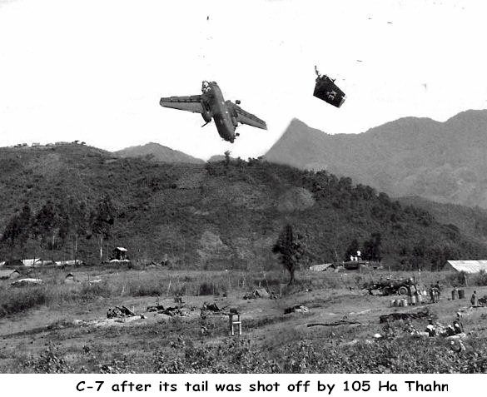
David Kowalski, the2skies@att.net
"Escape To U-Tapao"
I read an article "ESCAPE TO U-TAPAO" in the C-7A Caribou Association April News Letter. I was part of a group that flew 5 C-7A's out of U-Tapao in July 1975, my aircraft was 63-9755. I've researched a complete history of 755 since gear up out of U-Tapao to its final resting place. If you have any info on these C-7's from 1973-1975 please let me know. Especially any details of the months before we picked them up. I often wondered the story behind why we flew these A/C for over 13,000 miles, 94.3 flying HR. and 34 days from U-Tapao to Dothan AL, without AFTO 781 or any maintenance records. My hat is off to you for the hard and critical decisions you made saving our aircraft from the Communists . Thanks alot, CMSGT David A. Kowalski (RET.) TEL. 334-514-0804

